**Task 1:  
I first loaded the image using imageio and displayed it using matplotlib.**

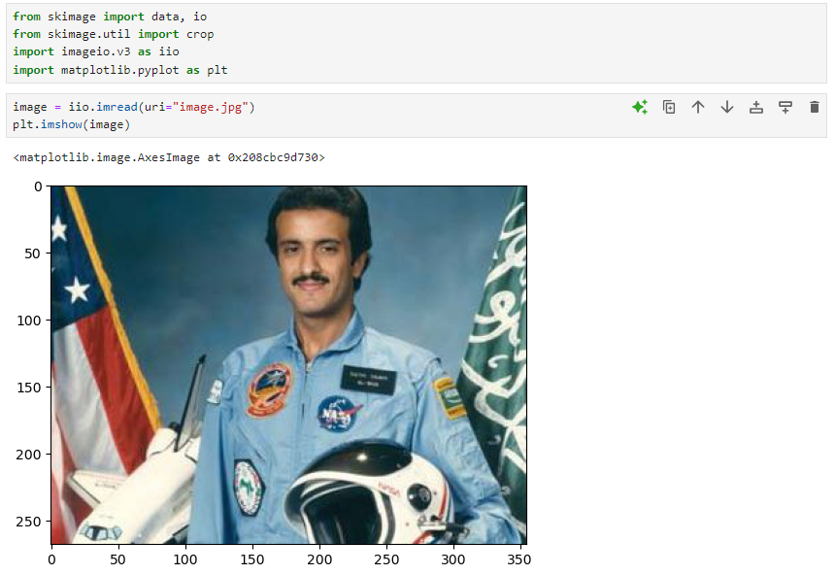

**Then, I applied cropping to extract only the shuttle portion.**

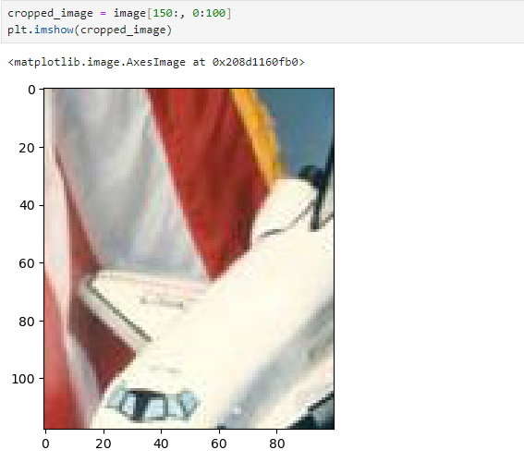

Then, I cropped the top-left region of the image. This portion of the image will be used to separate the Red, Green, and Blue channels. And here I displayed the red channel.

**Then, the green channel.**

Finally, the blue channel

**Task 2:**

From the first lab, I used the adjust_gamma to alter the brightness in the dog image.

